**TASK-3 CODE**

Q/A:-Create a component named sidebar. It should contain multiple tabs

Tab-1: Name- Header

Fields: Logo Path ,Logo Mobile Image ,Logo Link .Enable Switch ,

Tab-2: Name- Header Links

Fields: - Multifield:--Name ,Image

Tab-3: Name- SideBar Navigation

Fields: - Multifield ::-Desktop Icon ,Mobile Icon

Nested Multifield::-Navigation URL

Tab-4: Name- Region

Fields: -

Country - Dropdown - options (india & US)

Write sling model for above component and render the values on page using HTL

Note: For Multifield keep composite as true propertie

STRUCTURE FOR COMPONENT CREATION

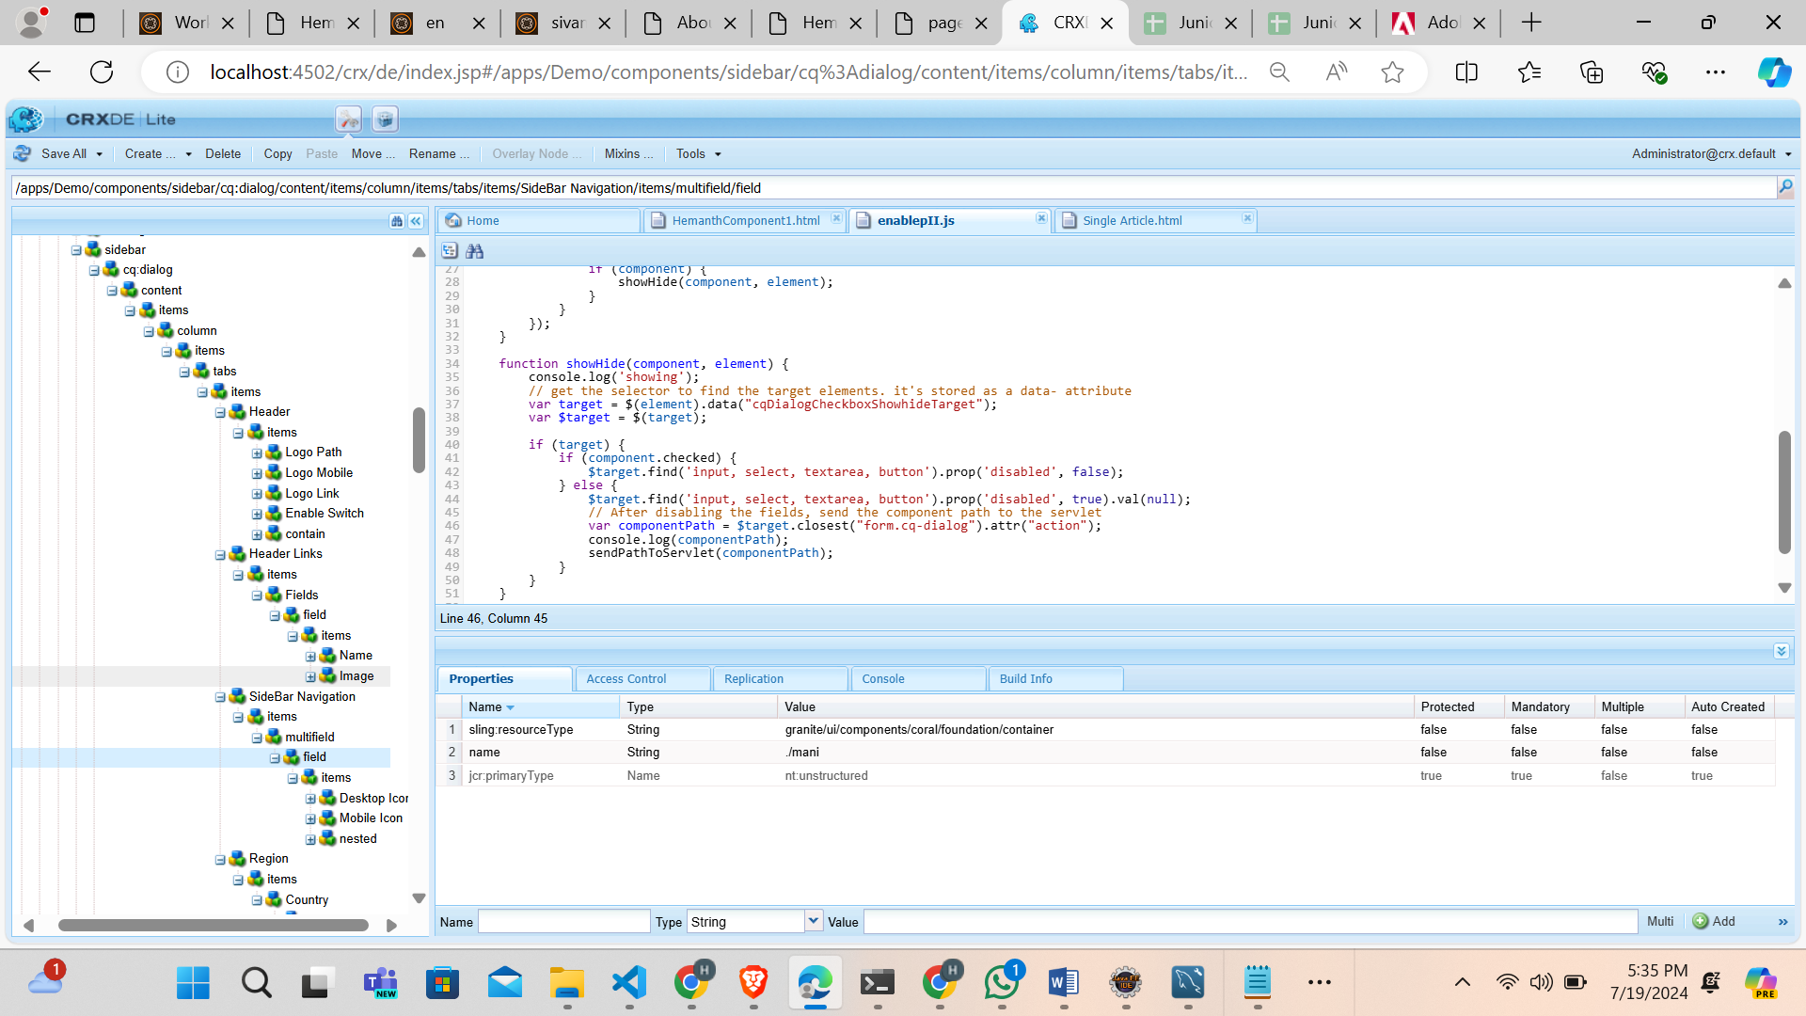

**HTL CODE FOR COMPONENT**

<div data-sly-use.side="com.adobe.aem.guides.demo.core.models.Sidebarproperties">

<h1>First tab Header</h1>

<div> <b>logomobileimage:</b> <img src="${side.logomobileimage }" alt="Tab 1 logo image"></div>

<div><b>logolink :</b><a href="${side.logolink }">${side.logolink } </a></div>

<div><b>logopath :</b> ${side.logopath }</div>

<div><b> enableswitch: </b>${side.enableswitch}</div>

<h2>Second Tab HeaderLinks</h2>

<div data-sly-list.secondtab="${side.details}">

<div><b> Name:</b><h3>${secondtab.name}</h3></div>

<div><b> Image:</b><img src="${secondtab.image}" alt="Tab 2 logo image"></div>

</div>

<h3> Third Tab NestedMultiField</h3>

<div data-sly-list.thirdtab="${side.mani}">

<div>

<h2>DeskTop icon : </h2><a href="${thirdtab.desk}"> ${thirdtab.desk }</a>

</div>

<div>

<h2>Mobile icon : </h2><a href="${thirdtab.mob}">${thirdtab.mob}</a>

</div>

<div data-sly-list.nestedtab="${thirdtab.navi}">

<div>

<h2>Navigation Url : </h2><a href="${nestedtab.navisurl}">${nestedtab.navisurl}</a>

</div>

</div>

</div>

<h3><b> <u>Region</u> :- </b></h3>

<div><b> country:</b> ${side.country }</div>

</div>

**CQ: DIALOG FOR COMPONENT**

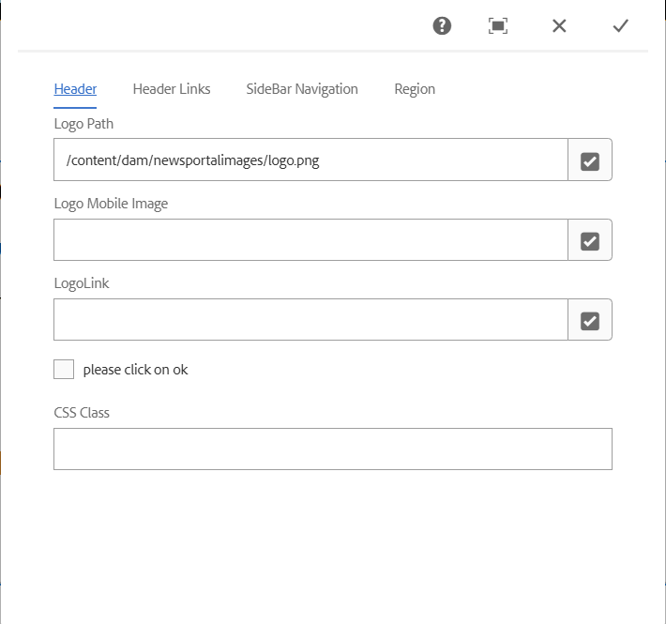

**SLING MODEL CODE**

package com.adobe.aem.guides.demo.core.models;

import java.util.List;

import org.apache.sling.api.resource.Resource;

import org.apache.sling.models.annotations.DefaultInjectionStrategy;

import org.apache.sling.models.annotations.Model;

import org.apache.sling.models.annotations.injectorspecific.ChildResource;

import org.apache.sling.models.annotations.injectorspecific.ValueMapValue;

@Model(adaptables = Resource.class,

defaultInjectionStrategy = DefaultInjectionStrategy.OPTIONAL

)

public class Sidebarproperties {

@ValueMapValue

public String logomobileimage;

@ValueMapValue

public String country;

//

@ValueMapValue

public String logolink;

@ValueMapValue

public String logopath;

@ValueMapValue

public String enableswitch;

@ChildResource

public List<Details> details;

@ChildResource

public List<Multifieldtab3> mani;

public List<Multifieldtab3> getMani() {

return mani;

}

public List<Details> getDetails() {

return details;

}

public String getLogomobileimage() {

return logomobileimage;

}

public String getCountry() {

return country;

}

public String getLogolink() {

return logolink;

}

public String getLogopath() {

return logopath;

}

public String getEnableswitch() {

return enableswitch;

}

}

**MULTIFIELD CODE**

package com.adobe.aem.guides.demo.core.models;

import java.util.List;

import org.apache.sling.api.resource.Resource;

import org.apache.sling.models.annotations.DefaultInjectionStrategy;

import org.apache.sling.models.annotations.Model;

import org.apache.sling.models.annotations.injectorspecific.ChildResource;

import org.apache.sling.models.annotations.injectorspecific.ValueMapValue;

@Model(adaptables = Resource.class,defaultInjectionStrategy = DefaultInjectionStrategy.OPTIONAL)

public class Multifieldtab3 {

@ValueMapValue

private String desk;

@ValueMapValue

private String mob;

@ChildResource

public List<Nestedtab3> navi;

public String getDesk() {

return desk;

}

public String getMob() {

return mob;

}

public List<Nestedtab3> getNavi() {

return navi;

}

**}**

**NESTED MULTIFIELD**

package com.adobe.aem.guides.demo.core.models;

import org.apache.sling.api.resource.Resource;

import org.apache.sling.models.annotations.DefaultInjectionStrategy;

import org.apache.sling.models.annotations.Model;

import org.apache.sling.models.annotations.injectorspecific.ValueMapValue;

@Model(adaptables = Resource.class,defaultInjectionStrategy = DefaultInjectionStrategy.OPTIONAL)

public class Nestedtab3 {

@ValueMapValue

private String navisurl;

public String getNavisurl() {

return navisurl;

}

}

**DISPLAYING CONTENT ON PAGE**

